
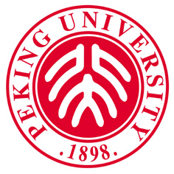

PEKING UNIVERSITY
中国100871 北京市海淀区颐和园路5号
Office of International Relations,
Peking University, Beijing 100871, China

全球同上一堂课 学生申请表
Application Form for Global Virtual Classroom Courses

- 申请人情况/Personal Information
姓名  Name | 英文姓名（以护照用名为准）  In English (Same as in your Passport) | 姓/Family name： |  | 照  片  Photo
姓名  Name | 英文姓名（以护照用名为准）  In English (Same as in your Passport) | 名/Given name： |  | 照  片  Photo
姓名  Name | 中文姓名（如果有）  In Chinese（If appropriate） |  |  | 照  片  Photo
性别  Sex |  | 国籍  Nationality |  | 照  片  Photo
出生日期 ____ 年____月______ 日  Date of Birth Yr. Mon. Date |  | 母语  Native language
最后学历
Education level
目前所在学校、年级及专业
Grade, major and currently enrolled university
联系电话（手机）/Tel(Mobile)： |  |  | Email：

2. 所选课程/Course selected
所选课程/Course selected
1.
2.
3.
4.

我承诺：以上信息为本人如实填写。本人在参与北京大学“同上一堂课”课程期间，不录制、不公开、不转播课程的所有内容或资源。如引起知识产权异议和纠纷，由本人承担法律责任。
I hereby affirm and promise: I have filled out the above information truthfully. During my participation in the "Global Virtual Classroom Course" at Peking University, I will not record, disclose, or rebroadcast any of the content or resources of the course. If I do, and/or my actions result in an intellectual property objection or dispute, I am aware I will have to bear any legal responsibility arising from it.

Signature:

